Innovation of Smart parking

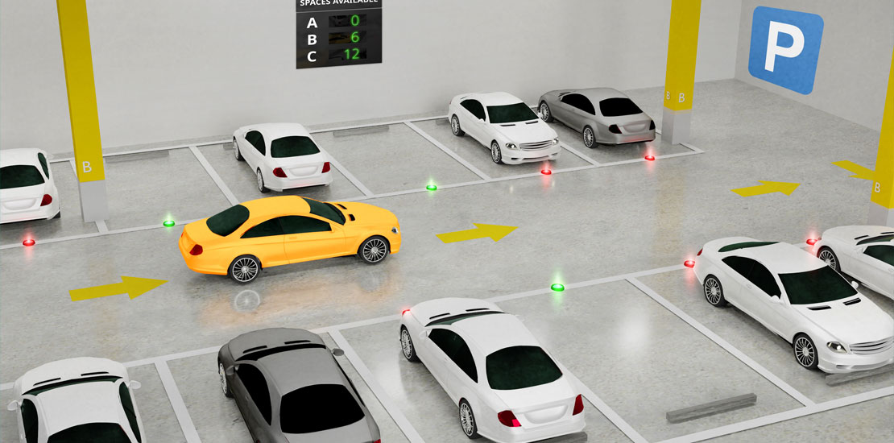

1.Stacked parking

Double-decker parking solutions do just that–double your parking space. Their technology uses a simple elevation function. When you find your spot, you drive onto a ramp. When you exit your car you can flip a lever for the ramp to raise. This frees up a parking space underneath.

The downside to this is a higher level of organization. For employers, it’s best to allocate parking spaces so those who leave later park first. This allows a smooth transition for car owners who leave earlier.

These options work best for;

* Car dealerships
* Mechanic Workshops
* Ferry crossings
* Private residence
* Robot valet parking

The conception is indeed smart, but the realization can be tricky. The onus is to first identify your need, evaluate the current parking timings, and proceed to choose the best solution.

2.Subterra parking lifts

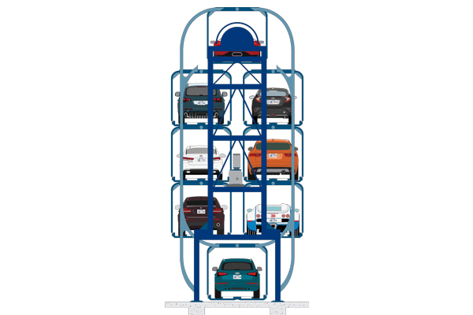

This smart parking solution is designed with homeowners in mind. After you park your car in your garage and exit it, your car is lowered to a subterranean space.

Many private homes come with basements and underground garages. Store your cars here, choose which one you prefer to drive, mount the lift and drive away without a congested driveway.

Also popular with inner city parking garages. Employing automated parking valets, they can now utilize underground space without needing to spend too much on human navigation.

Your car will be automatically transported to an available parking spot underground, possibly tiered, optimizing space to the max, but more on that below.

3.Solar panels parking shadows

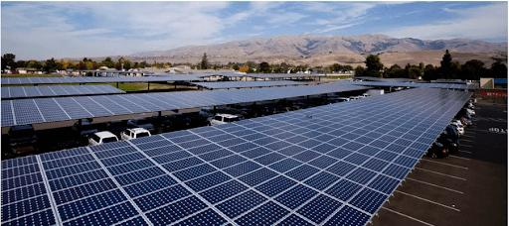

Marrying smart parking and renewable energy, this innovation is just the tip of the iceberg. For outdoor parking lots, installing solar panels as shades offer the following:

* Parking safe from drastic weather conditions
* Reduced opportunity for bird dropping to dirty your car
* Production of energy while optimizing space

Lot owners can feed the energy back into the grid and benefit from local tax cuts. Or, if the parking area is operating an APS they break even with energy consumption.

These schools in California benefitted from reduced electricity fees for up to 20 years. Smart parking innovation at its finest! And it instills a sense of green forward-thinking in the students too to boot.

4.Reduced fees for EVs

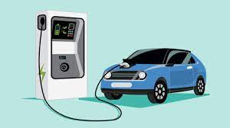

This innovation for smart parking promotes the use of electric vehicles. An objective for smart cities is to reduce carbon emissions. Therefore, it makes sense to offer lower parking rates for EVs. Smart move.

In conjunction with smart parking apps and designated EV charging stations, you can brave inner city parking with your EV.

If you don’t need to charge your car each time you park it, you can apply for a residential parking permit at a reduced cost. There’s no one price however, it fluctuates depending on local councils, but definitely worth looking into.

5.Robot valet parking

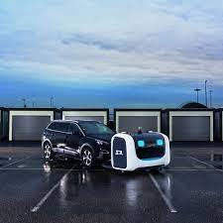

According to IEEE, Robotic Valet Automated Parking Systems (APS) is a viable solution to the parking problem. Designed initially for dedicated parking lots, the automated parking service saves car owners time and gas looking for available space.

When you enter the lot you drive your car onto a sort of loading dock. With the help of an app, you can leave your car and let the robotics do the rest.

The dock automatically transports your car to the nearest free space. This reduces accidents, saves space, can use parking lifts, and boosts the overall efficiency of the parking garage.

In the unlikely event of any mishaps, the services of a dedicated car accident lawyer are readily available to provide expert guidance and support.

Conclusion

As a conclusion, this project will help in reducing the amount of time a driver has to spend around the parking just to find an available spot, reducing the amount of traffic around the parking and also reducing the bad parking around the parking space.